Social Emotional Faces Behind the Masks

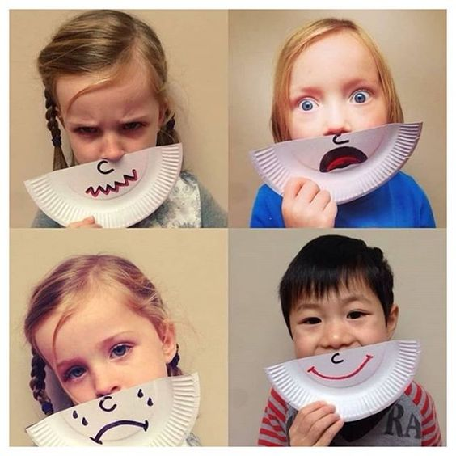
https://www.pinterest.com/pin/24488391712648199/

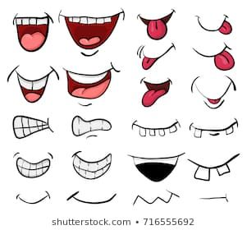https://www.pinterest.com/pin/508484614176806385/

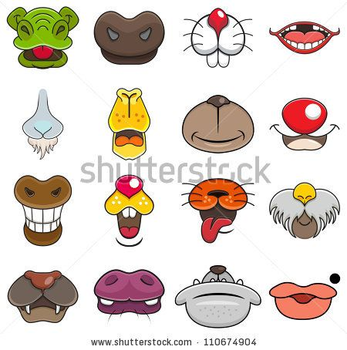https://www.pinterest.com/pin/45106433743459769/

