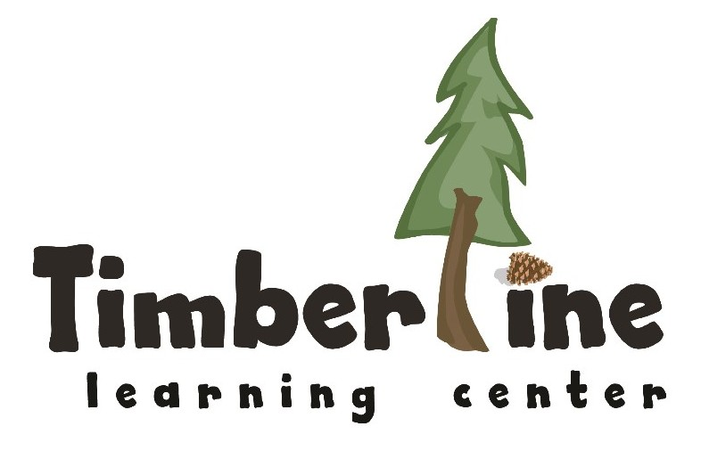
Early Childhood Assistant Director
Breckenridge, CO

Reports to: Executive Director Employment Type: Full-Time, Year-Round
Start Date: September 1, 2026 Compensation: $75,000 – $90,000 annually (depending on experience)

Position Purpose
The Assistant Director (AD) is a vital connector for Timberline Learning Center, building the operational and relational infrastructure that lets teachers focus on children and helps families feel welcome, from first contact through prekindergarten graduation. As a strategic partner to the Executive Director and Instructional Coach, the AD manages the school's enrollment, compliance, communications, and resources, and oversees facilities so the physical environment supports learning as the “third teacher.”
In close partnership with the Executive Director, the AD helps strengthen school culture, grow family and volunteer engagement, support fundraising and new program development, and ensure a positive experience for staff, children, and families.

Key Responsibilities
Leadership Partnership
- Serves as a key member of the administrative team. Advances the school mission and models TLC’s essential expectations
- Collaborates effectively with internal and external community members; bilingual skills valued
- Supports the Executive Director with grant writing, fundraising initiatives, and digital promotion
Financial Management & Purchasing
- Process tuition payments, manage parent billing, and administer tuition assistance programs
- Track CCAP and Summit Pre-K (SPK) subsidy documentation
- Create monthly snack menus within budget. Order snack and coordinate support staff preparation and delivery
Enrollment & Family Engagement
- Manage the admissions process: tours, waitlist, enrollment packets, and new family onboarding
- Communicate with prospective families and maintain accurate records and contact lists, and schedule admissions meetings
- Collaborate with Instructional Coach to plan program move-ups and prepare families and teachers for transitions
- Build trusting relationships with families and represent TLC's philosophy to prospective families and the community
- Recruit and coordinate volunteers for projects and donations. Track volunteer hours, receipts and fees
Licensing, Health & Safety Compliance
- Maintain student files in compliance with licensing requirements, including CIIS immunization records; identify and follow up on deficits with families
- Prepare for and support childcare licensing inspections
- Administer medication per regulations, track illness, and liaise with admin. Team, school nurse and public health on health matters and communications
- Oversee health screenings, medication logs, injury reports, fire drills, and disaster preparedness
- Coordinate emergency and fire drills, maintain drill logs, organize first aid and emergency supplies
Office & Facilities Management
- Ensure professional communication by greeting guests and visitors upon entry and exit, answering phones, taking and distributing messages, and creating a welcoming and supportive space
- Maintain a safe, clean, and organized school environment, including common areas, storage, building and playgrounds
- Manage front desk operations, facility upkeep, and ordering of classroom/office, art, and janitorial supplies
Scheduling & Staff Support
- Manage substitute teacher recruitment, scheduling, and coordination
- Develop and maintain staffing schedules
- Partner with Instructional Coach on staff scheduling tied to coaching, training, and documentation time
- Support mentor teachers with classroom administrative tasks, coverage, and restocking of supplies

Administrative Projects
- Maintain important lists: classroom contacts, rosters, staff phone/email, attendance records
- Coordinate details for staff and board meetings and professional learning days (schedule, set up/break down, order food, beverages, and paper goods). Prepare meeting space and materials
- Deposit checks, monitor P.O. box, and run school errands as needed for snack and school supplies
- Support the development of new programs and school projects
- Additional facility maintenance support as needed

Required Qualifications
- Valid Large Center Director Qualification (State of Colorado) and active PDIS Level III or higher
- Bachelor’s degree in Business Administration, Early Childhood Education, or a related field
- 3+ years of administrative, assistant directing, or operational leadership experience in an early childhood setting
- Strong administrative, operational, and financial acumen, including office management, purchasing, and vendor/billing experience
- Working knowledge of Colorado childcare licensing regulations
- Appreciation for the Reggio Emilia philosophy and the ability to communicate its value to families

Preferred Qualifications
- Master's degree in Educational Leadership, Early Childhood Education, Non-Profit Management, or Business/Finance
- Deep knowledge of child development, emergent curriculum, and the Summit County early childhood landscape
- Experience with QuickBooks, Excel or student information/database systems
- Bilingual (Spanish/English) abilities
- Proven ability to build, support, and retain strong teams

Personal Attributes & Working Style
- Warm, customer-service orientation that builds trust with families, staff, and community partners
- Collaborative, curious, and a good listener; culturally competent and equity-minded
- Calm and professional under pressure, with strong discretion and attention to detail
- Ability to prioritize competing responsibilities, stay fully present, and switch gears as needed
- A relationship-driven leader who serves as a trusted partner to the Executive Director

Professional Development & Compliance

Ongoing Expectations:

Attend orientation, training sessions, admin. meetings, school events and monthly staff and board meetings

Complete 1 hour of annual volunteer work for TLC fundraising events

Maintain compliance with all state licensing standards (DHHS, Public Health, Environmental Health, Fire, Police)

Immediately report any safety concerns or facility damage to supervisors

Adhere to all TLC Employee Handbook policies and procedures

Fulfill essential expectations and responsibilities of role

Additional duties as directed.

Working Conditions
- Flexible schedule including occasional early mornings, evenings, or weekends
- Ability to lift up to 40 pounds, move quickly, and engage at children's level (bending, kneeling, sitting on the floor)

