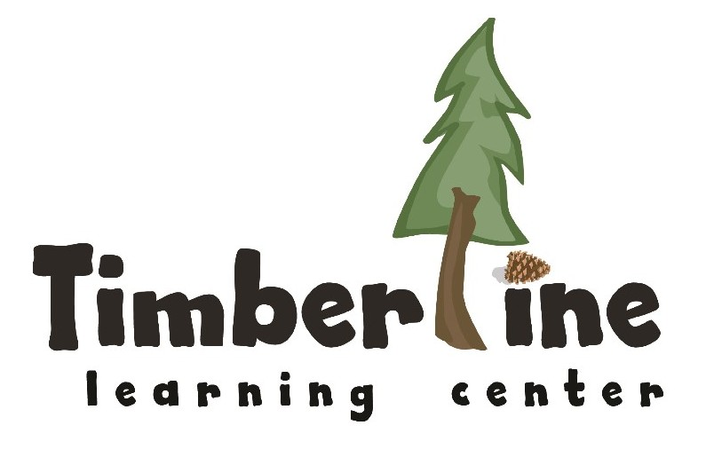

Position Title: Co-teacher
FLSA Classification: Non-Exempt
Reports to: Executive Director
Position Purpose: To foster children's growth as learners by supporting the Mentor Teacher in delivering a responsive, play-based daily program grounded in the Reggio Emilia philosophy and in partnership with families.

Core Responsibilities
Learning Environment & Curriculum
- Design and maintain a welcoming, aesthetically rich environment responsive to children’s interests and developmental needs
- Partner with the mentor teacher to plan and implement an emergent, constructivist curriculum
- Facilitate child-led investigations and project work that honor children’s natural curiosity
- Document and make children’s learning visible through journals and classroom displays
Child Guidance & Development
- Build genuine relationships with each child, honoring their unique strengths and developmental journey
- Use positive, developmentally appropriate guidance strategies to support social-emotional growth
- Conduct quarterly assessments using Teaching Strategies GOLD and adjust approaches to meet individual needs
- Maintain accurate, thoughtful records of children’s progress
Family & Community Engagement
- Build authentic partnerships with families through open, consistent communication
- Facilitate formal parent-teacher dialogues twice annually
- Share weekly newsletters, progress reports, and updates on classroom curriculum and individual children
Team Leaderships
- Engage in daily team communication to share observations and plan responsively
- Participate in team meetings, staff meetings, and professional learning communities

- Represent Timberline Learning Center with integrity in all community interactions
Professional Growth
- Model and uphold the highest standards of early childhood education practice
- Stay current on research and best practices, integrating new knowledge into curriculum and classroom work
- Set and pursue professional learning goals in collaboration with the Instructional Coach

Qualifications:
- Associates degree or higher in education or an education related field
- Minimum one year of experience working with children ages 0-6
- Full-time, year-round availability
- Stable housing in Summit County or surrounding areas
- Ability to pass comprehensive background check (fingerprinting and child abuse registry)
- Growth mindset with commitment to ongoing professional development
- Strong communication skills (oral, written, and digital)
- Demonstrated flexibility, problem-solving abilities, and organizational skills

Preferred:
- Coursework in Early Childhood Education
- Colorado Shines PDIS Level 2 Credential or above
- Current CPR and First Aid certification (or willingness to obtain within 30 days)
- Familiarity with Reggio Emilia Approach, Project Approach, or play-based learning philosophies

Professional Development & Compliance
First-Year Requirements:
- Achieve Colorado Shines Level 2 Credential minimum
- Complete ECE 1011 and ECE 1031 coursework
- Develop working knowledge of Reggio Emilia principles and implement key tenets

Ongoing Expectations:
- Attend orientation, training sessions, monthly staff meetings, and parent-teacher conferences
- Complete 1 hour of annual volunteer work for TLC fundraising events
- Maintain compliance with all state licensing standards (DHHS, Public Health, Environmental Health, Fire, Police)
- Immediately report any safety concerns or facility damage to supervisors
- Adhere to all TLC Employee Handbook policies and procedures
- Fulfill essential expectations and responsibilities of role
- Additional duties as directed.

Physical Requirements:
- Lift and carry up to 45 lbs occasionally (supplies, equipment, assisting children)
- Regularly sit, kneel, and work at floor level or on child-sized furniture
- Actively supervise children throughout all facility areas (classrooms, playgrounds, common spaces)
- Work indoors in climate-controlled settings and outdoors in variable weather conditions
- Potential exposure to common childhood illnesses

