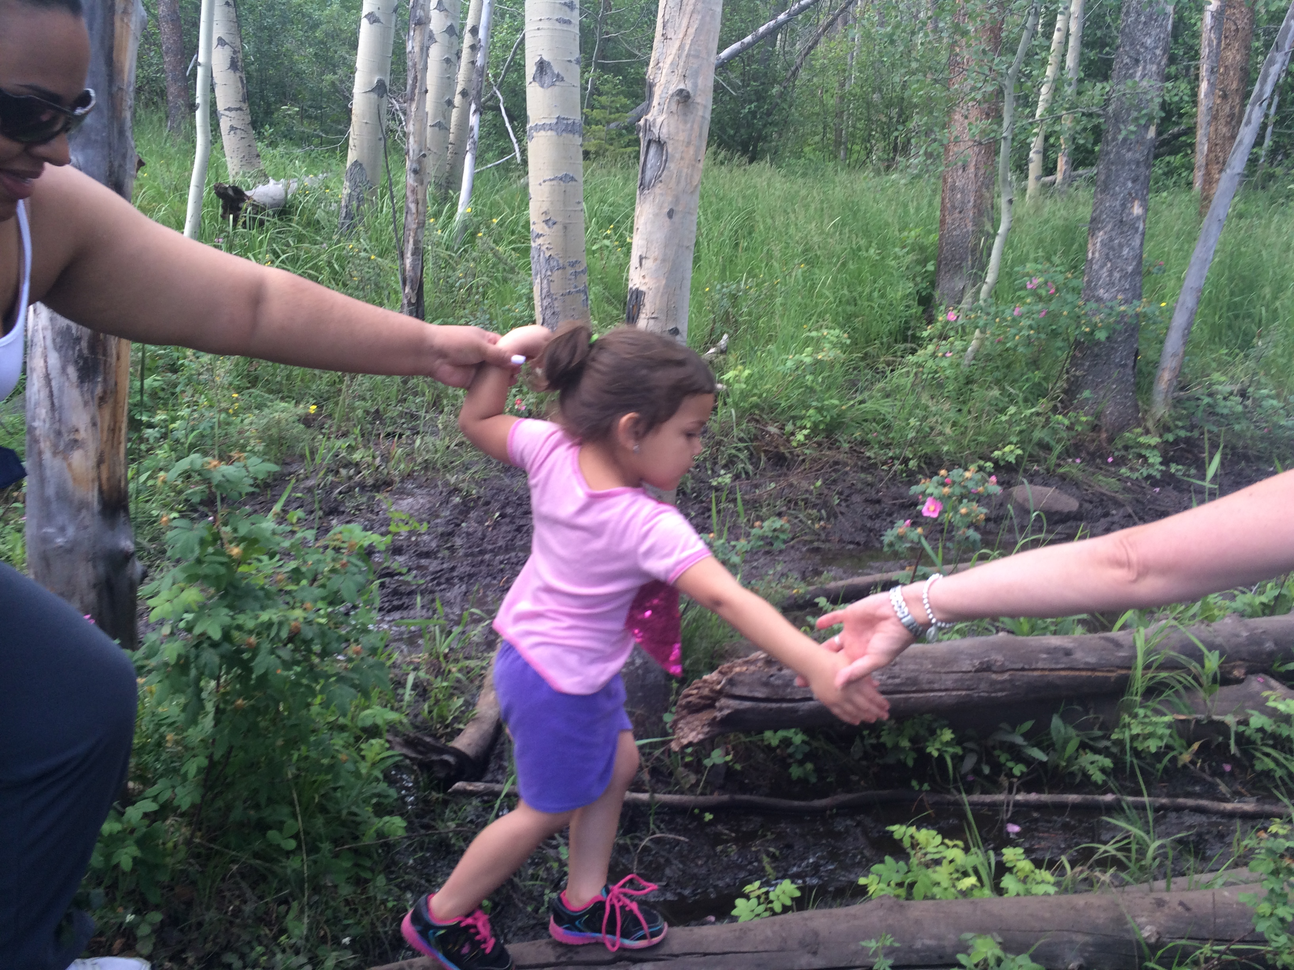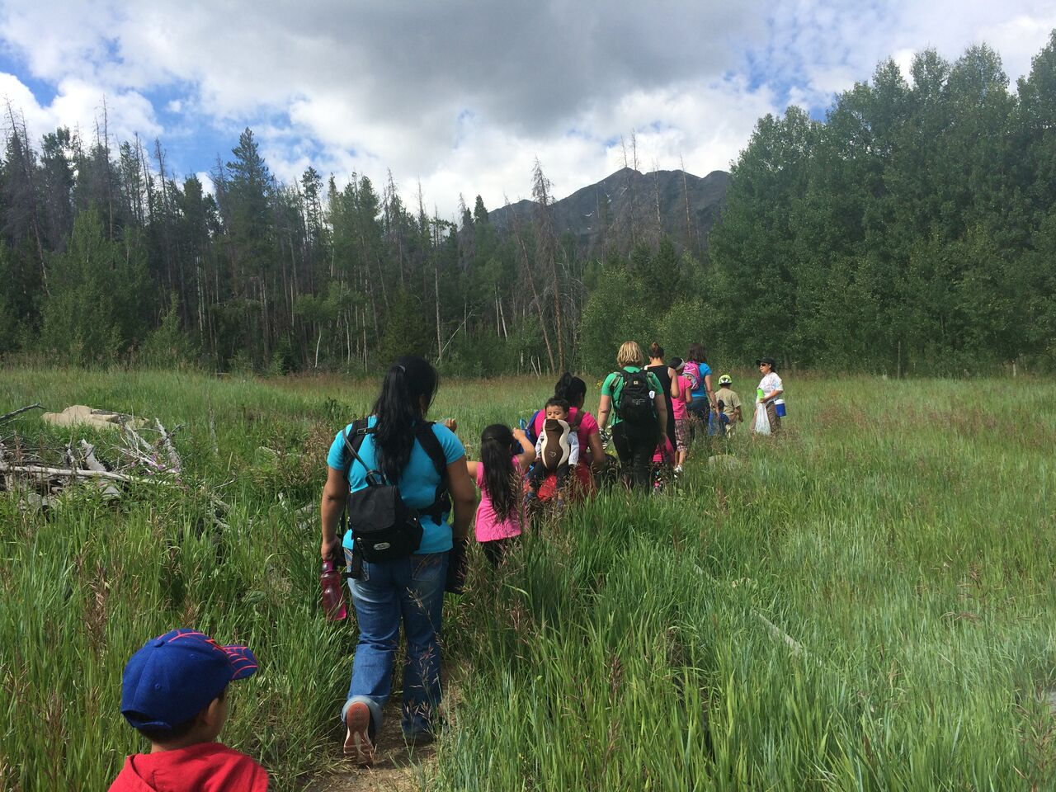

Early Transitions

Summit County, Colorado

Start date at new program:

________________

To:

**_________________**

(name of new program)

**This is ME:**

From:

**_________________**

(name of current program)

**This is ME:**

#### Child’s Name:

#### ________________

Why share this brochure?

* Your child is moving on to a new program or school. This can be exciting, fun and/or scary for a young child (and you)!
* Your child’s caregiver, teacher and/or friend will compete this brochure with important information they have learned while working with your child.
* We all want you and your child to be successful in this move.
* This brochure is designed to help your child’s new caregivers help your child feel comfortable in their new setting.
* It is *totally* up to you (the parent) if you want to share this brochure with your child’s new program or school. You are your child’s 1st and most important teacher!

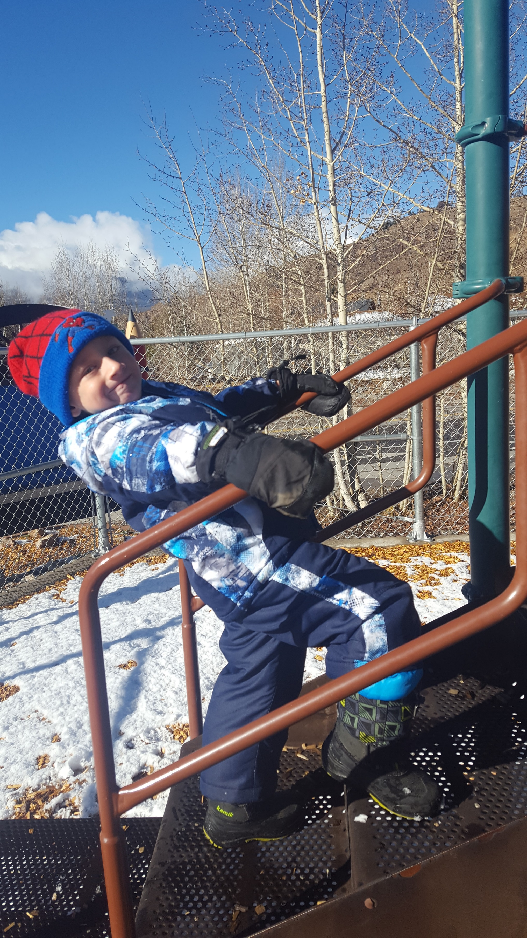

**Contact at current program:**

____________________________

Staff Name

**Contact at new program:**

____________________________

Staff Name

**By signing below, you give your child’s current and future caregivers permission to speak to each other to help make this a smooth transition for your child.**

PARENT/GUARDIAN SIGNATURE:

______________________________

DATE: _______________________________

Moving

On…

Program to Program

## **Transitions**

This section is to be completed about the child by the child’s teacher, provider

and/or friend at current program.

**Has lived in Summit County for:**

______________________________________

**Parents are:** (*Circle one*)

Together Separated Divorced

**Primary caregivers are:**

______________________________________

**Participated in the following programs:**

*(Circle all that may apply)*

Strengthening Families (CICP)

Nurse-Family Partnership (NFS)

Summit Head Start 0-5

FIRC Families United

Early Intervention

Home Care: _____________________________

Preschool: ______________________________

Other: ________________________________

Loves to:

Doesn’t love to:

We’ve been working on:

Notes on routines, meals and/or anything else I think might help in the transition:

This section is to be completed by the child’s parent/guardian.

## About ____________

## (Child’s Name)